Direct drive wind turbines main bearings CMS trade-off: methodology proposal and case study
Haral Jonas Serafini
Department of Development and Technological Innovation
WEG Equipamentos Elétricos S.A.
Av. Waldemar Grubba, 3000, 89256-600, Jaraguá do Sul, SC, Brazil
harals@weg.net
paper
Direct drive (DD) wind turbine main bearings have just a few parts, providing higher reliability, but replacement may be very expensive. Wind turbines maintenance strategies include the use of Condition Monitoring Systems (CMS) to prevent unexpected downtime. This paper proposes a methodology to define whether to install a CMS in such systems. It provides an innovative suggestion that primary failure in further systems that would lead to main bearings secondary failures should also be part of CMS evaluation. A case with WEG AGW 2.2 wind turbine is partially described. With given assumptions, the results indicate that a CMS that could detect primary failures may have advantages over other CMS if the detection could avoid the bearing failure. The methodology proposed in this paper may help operators to decide when to install CMS and what features should be required.
Keywords: Direct Drive Wind Turbine, Main Bearing, Condition Monitoring System.

PROPOSE OF THE WORK
Wind turbines O&M (Operation & Maintenance) strategies for execution and optimization depends highly on reliable data from PdM (Predictive Maintenance) programs. Main components deterioration data acquisition and effective processing is mandatory to identify potential root cause of failures or failure in early stages.
Direct drive (DD) wind turbines main bearings systems provide a very interesting case for PdM programs. In one hand, their reduced number of components provide good reliability, especially when good design, manufacturing and assembling techniques are followed. In another hand, once generator generally integrates the main bearings in it, in some cases it is necessary to disassemble the entire heavy, big diameter generator in case main bearings are damaged, which demands a huge logistic field operation at the site including a massive crane.
This paper suggests that the selection of a main bearing CMS demands a careful trade-off analysis by wind turbine operator, in order to mitigate risks of the related uncertainties and to optimize CMS costs. LCC (Life-Cycle Cost) analysis is proposed as method for such trade-off, as well as suggestions for assumptions and parameters to be chosen.

APPROACH

Direct Drive Main Bearings
Gearless wind turbines main bearings could present several design topologies [2] as per examples of Figure 1.
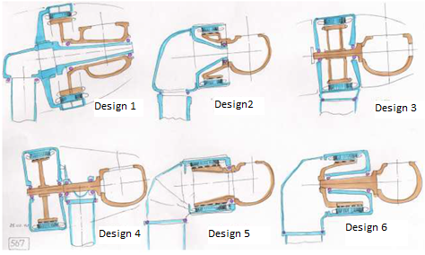
Figure 1 - DD wind turbine arrangements for innter generator rotor (adapted from [2])
One particular feature of eventually all DD main bearings arrangements is the intervention cost needed for bearing replacement. As per Figure 1, for example, it is always necessary to remove at least one big component, that it could the blade rotor, the generator, both or the entire tower top. In all cases, a high weight capacity, high height crane is necessary. Such cranes are very expensive, and could reach almost the order of millions of Brazilian Reais, including mobilization, demobilization and operation hours. Industry experience shows also that anticipating the date of a field operation does not change too much the cost of the crane.
Another particular feature is that they are generally pre-loaded bearings. Pre-loads are applied in bearings to prevent looseness under external applied loads conditions that may lead to shocks that could generate small defects in the bearing surfaces favoring pitch or cracking along the time.

Reliability of DD Main Bearings
Reliability of main bearings can be assumed to follow Weibull distribution [3]. Equation 1 shows the 3-parameters Weibull cumulative distribution function.
$F\left(t,β,η,γ\right)=1-e^{(-{\left(\frac{t-γ}{η}\right)}^{β})}$ Equation 1
Where:
F (t, b, h, g) = cumulative distribution function
b = shape parameter (or slope)
h = scale parameter (or characteristic life)
g = location parameter
For main bearings, shape parameter b could be assumed constant. Proper values can be found with bearing suppliers or in literature.
Scale parameter h can be estimated given a calculated rating life. In this case, the Eq. (1) is solved for h giving certain t that equals a calculated “Ln”, being “Ln” a number of hours with accumulated probability of failure n. For example, given main bearing calculated service life of L10 = 17.000hrs, Equation 1 is solved for h, with a proper b and g, given t = 17.000hrs and given f (17.000hrs) = 10%. Location parameter g is in hours and could be assumed 0,05*L10, being L10 the main bearing calculated bearing rating life for 10% of bearings population.
For the purpose of this paper, it is convenient to understand all possible causes that could lead to a certain failure. The technique used here for this purpose is the Fault Tree Analysis (FTA). A typical wind turbine main bearing FTA could be found in [4].
CMS performance fundamentals can be found in literature. Detectability and efficiency are used to model the performance of an imperfectly performing CMS [5]. Detectability is the capability of a system to identify a certain failure mode that has happen. Efficiency is how long the CMS indicates the failure mode before this failure mode leads to complete loss of component function. In this paper, efficiency is assumed with an arbitrary time allowing the corrective maintenance be planned without incurring in big penalties resulting from unexpected failure. Detectability is assumed as the capacity of a CMS to identify a failure in such arbitrary time.
For DD wind turbines, these fundamentals are particularly interesting because, in case main bearing change be necessary, a costly crane intervention is demanded (as discussed before in this paper). Even with a high performance CMS, with high detectability in very early stages of failure, such failure will still evolve along the time even though being monitored by maintenance operator. Therefore, even the best performance CMS will not be sufficient to avoid such intervention cost in case a bearing damage happens. Costs avoided by the CMS will be limited to the eventual penalty costs and / or the wind turbine lost power production. In this paper, it will be assumed that each bearing identified with a failure will demand a crane for immediately replacement. However, this may not be the case once the crane can be contracted to disassemble more than one component. Finally, it is also expected that, after a bearing damage is identified, the bearing could run several months before replacement is necessary. Both these possibilities are not explored in this paper.
It is convenient to include in the analysis an innovative approach to evaluate CMS techniques suitable to identify not just a bearing failure, but also operational conditions that hypothetically could lead to it. For this reason, bearing failures were categorized as second order failures, while such operational conditions that lead to them will be considered as primary failure from now on. Three critical operational parameters are considered primary failures of upmost importance: bad lubrication condition, loss of pre-loading and undetected non-conformities in bearing manufacturing/design. Fatigue bearing failures are considered primary failures at all once bearings service life calculation includes phenomena associated to all operational parameters.
Bad lubrication could be caused by grease contamination due to external entrance of dirt, water or other substances; contamination due to particles from occasional wearing that are not cleaned out during re-greasing; lack of grease; and others. A bad lubricated bearing will present insufficient oil thickness that will lead to frequent wearing, causing or improving defects on the rolling elements. Lubrication failure probability depends on the wind turbine design and maintenance practices. For example, manual lubrication systems are expected to have higher probability of failure than monitored automatic lubrication systems. Number and design of seals affects the enclosure of the region with grease and therefore affects lubricant integrity. Frequency of old grease laboratory analysis also can help to identify lubrication probability.
Loss of pre-loading could be caused by relaxation of elements that keep the bearing pre-loaded, like bolted joints or plastic deformation of bearing tracks. Pre-loading relaxation probability depends on the wind turbine manufacturing control in the bearings preload at the assembling shop, bolted joints structural margins and number of torque/tension inspections during maintenance operations.
Undetected non-conformities in main bearing manufacturing or design could include raw material chemical composition problem, wrong chosen or applied thermal treatment, out of tolerances dimensions, incorrect finishing, sharp corners, incorrect estimative of operational temperature, error in the boundary conditions of the analysis, incorrect estimative of external loading. Manufacturing and design failures are expected to be more frequent according to the experience of the bearing supplier and its quality control. Main bearing, in this context, includes not just the rings, rollers and cage, but also mating components, like shaft, housing, etc.
For the purposes of this paper, no other primary failures were considered.
It is also necessary to estimate probability for each one of the primary failure modes happens. For lubrication system and manufacturing / design problems, the “bathtube shape” curve (for more details about it, see [6]) is suggested.
A primary failure not necessarily leads to a bearing failure. A probability of occurrence of second failure in the case of occurrence of a primary one can also be defined.

LCC Method
Life-Cycle Cost Analysis (LCCA) is a technique suitable for the evaluation whether an investment should be done with given possibility to avoid further expenses. Some literatures have reported LCCA [5] [1] as proper analysis to support the decision of whether to choose a CMS to monitor wind turbines. LCCA shall include modeling of an imperfectly performance CMS [5].
LCCA of wind turbines should assume at least the following groups of costs Cm:
${Cm}_{i}={Cin}_{i}+{CSp}_{i}+{CCm}_{i}+{CPm}_{i}+{CPe}_{i}$ Equation 2
Cm = Maximum cost for a failure i in a given period; CIn = Investment cost of condition monitoring system; CSp = Spare Parts cost of new asset; CCm = Corrective maintenance cost; CPm = Predictive maintenance cost; CPe = Penalty costs due to downtime.
The exact cost in each period is depends on the probability of occurrence of each event:
$C_{j}=p_{i,j}*{Cm}_{i,j}$ Equation 3
p_{i,j} = probability of occurrence of a given cost event due to a failure i in a period j; depends on the FTA and CMS detectability.
All values of cost Cj are levelized in the time by applying present net value:
$LCC= \sum_{j=0}^{20}{\frac{C_{j}}{{(1+WACC)}^{j}}}$ Equation 4
WACC = Weighted Average Cost of Capital
Several scenarios could be run after these definitions and a comparison between them could be made. One simple scenario is not to have a CMS in the main bearings. Additional scenarios could be added changing any assumption, but particularly interesting is to compare more than one CMS performances, give the extensive possibilities of CMS options [4] [6] [1].

Case Study
A hypothetical case study of WEG AGW 2.2 wind turbine is presented. Some of the data is shown, but some proprietary information is not disclosed and appears “confidential”.
AGW 2.2 main bearings have a design topology that demands removal of rotor to disassembling the main bearings.
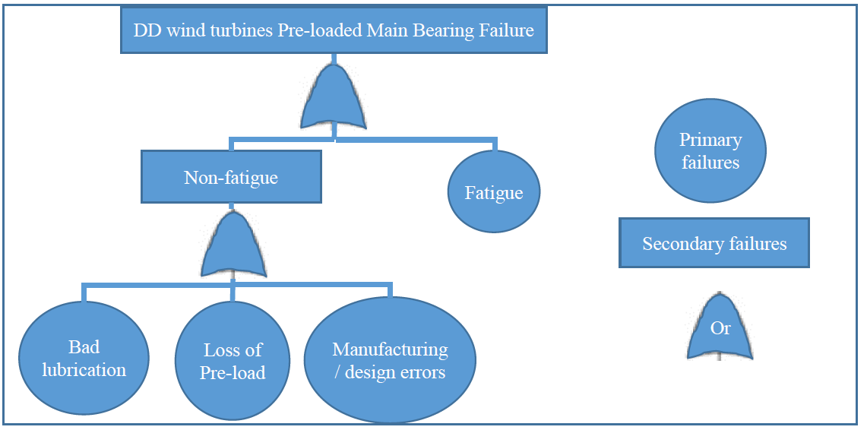
Graph 1 – FTA for DD wind turbines pre-loaded main bearings
Table 1 – DD wind turbine CMS scenarios for trade-off
 | CMS | Primary failure detectability | Secondary failure detectability
Scenario 1 | Most expensive CMS | performance to capture 100% of lubrication failures in time enough for solving lubrication issue before a bearing failure happens; performance to detect 0% of pre-loading failures in time enough for making a pre-loading adjustment | performance to detect 100% of bearing failures in time enough to avoid unexpected stop
Scenario 2 | Cheapest CMS | performance to capture 20% of lubrication failures in time enough for solving lubrication issue before a bearing failure happens; performance to detect 0% of pre-loading failures in time enough for making a pre-loading adjustment | performance to detect 100% of bearing failures in time enough to avoid unexpected stop
Scenario 3 | No CMS | No detectability. If bearing fails, it will cause unexpected stop.
The model includes main bearing reliability as Weibull cumulative distribution function as per Equation (1). Shape parameter (slope) and scale parameter (rating life) were obtained from supplier. Location parameter as defined previously in this paper. Probability of failure in each year was then calculated using the difference of cumulative probability of year j minus the cumulative probability of year (j -1).
The model considers a specific AGW 2.2 pre-loaded main bearing FTA as per Graph 1.
Three scenarios were created as per Table 1.
For all scenarios, the following assumptions apply.
- A primary failure as per Graph 1 could happen with probability as per Table 2. Primary failure could lead to a secondary failure as per Graph 1 with an assumed probability of 100%.
Table 2 – Probability of a primary failure along wind turbine main bearings lifetime
 | Year 1 and 2 | Year 3 to 18 | Year 19 and 20
Bad Lubrication condition | 2,0% in year 1  1,5% in year 2 | 1,0% | 1,5% in year 19  2,0% in year 20
Loss of pre-loading | Twice the Weibull cumulative distribution of fatigue of the bearings.
Bearing manufacturing / design problems | Confidential | Confidential | Confidential
Fatigue | According Weibull cumulative distribution (see item 2.2)
- Corrective costs associated according to Table 3.
Table 3 – typical corrective maintenance costs associated with a main bearing failure
Cost of new set of bearings | Confidential
Cost to transport the failed generator to factory | R$ 67,000.00
Cost to disassemble/ assemble the bearings in the factory | R$ 14,489.34
Cost to mobilize / demobilize a suitable crane | R$ 750,000.00
Cost to transport new generator | R$ 67,000.00
Cost to replace generator | R$ 180,000.00
cost to regrease after alarm | R$ 1,000.00
cost of penalty for unexpected stop (8 weeks stop) | Confidential. Around 5 times the 1 week stop cost
cost of penalty for planned maintenance (1 week stop) | Confidential
This model was run for every year from zero to the wind turbine life-time, it means, 20 years. In each year, the associated LCC was added up to the sum. WACC was assumed 13%.

results
Graph 2 shows the Life-Cycle Cost (LCC) along the wind turbine lifetime, 20 years. It is normalized to preserve confidentiality of data. All three scenarios were included.
In 20 years, it is expected that a most expensive but with detectability of bad lubrication CMS leads to the lowest LCC. Not installing a CMS resulted in most expensive option, with around 125% normalized LCC.
Difference between scenario 1, with 100% normalized LCC, and scenario 2, with 120% normalized LCC, is very big. This is about three times the initial cost of the CMS considered in scenario 2. This is coherent with the fact that having a CMS that is not able to detect lubrication, pre-loading or manufacturing issues may not avoid one of the most expensive costs of maintenance, which is to have a crane to disassemble the entire generator for bearing replacement.
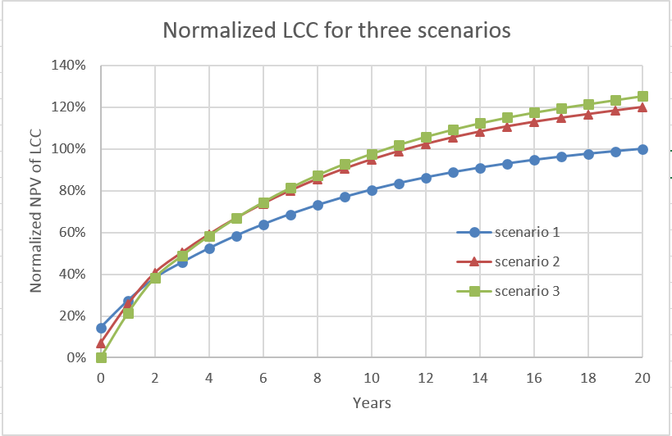
Graph 2 – Normalized LCC for three scenarios (see Table 1) of AGW 2.2 main bearings case
It is interesting to remark that the scenario 2, with low cost CMS, may lead to the understanding that it would not seem to be worthy: with 120% normalized LCC, it would almost the same LCC as having no CMS, 125% normalized LCC. However, it should be noted that this paper assumes contracting of the crane and replacement of the bearing immediately after CMS signalizing a fault. This is very conservative. The most realistic situation is that after the CMS indicates a failure in the bearings, the condition will then be followed-up and a proper maintenance strategy will then be applied to contract the crane in the best cost-benefit moment. This strategy may lead to several months (or even years with such low speed bearings) between the detection of the failure and the bearing replacement.

Conclusions
DD main bearings wind turbines are quite different of other wind turbine systems because their replacement requires a crane. In such cases, there is real value in installing a CMS for main bearings that would be able to prevent a main bearing failure by monitoring particular operational parameters.
The fact that results of the trade-off are relatively different suggests that use of the technique presented in this paper might have the potential to add value to the maintenance strategic decision, especially to decide whether to install a CMS for DD main bearings; and how to specify a CMS.
REFERENCES
- Conorado, D., Fischer, C. (2015) Condition Monitoring of Wind Turbines: State of the art, user experience and recommendations. Project Report Fraunhofer Condition Monitoring of Wind Turbines: State of the art, user experience and recommendations. Project Report Fraunhofer IWES, January 2015, January 2015
- Klinger, Friedrich - Müller, Lukas (2012). STATE OF THE ART and NEW TECHNOLOGIES OF DIRECT DRIVE WIND TURBINES. Congressional Research Service, Retrieved May 7th 2017 from the World Wide Web: http://www.wind-energy-research.de/Publikationen/public/filecache/pub017-2012-state-of-the-art-paper.pdf
- Ben Ali, J., Chebel-Morello, B., Saidi L., Malinowski, S., Fnaiech, F. 2014. Accurate bearing remaining useful life prediction based on Weibull distribution and artificial neural network. Mechanical Systems and Signal Processing 56-57 (2015) 150-172.
- Marquez, F. P. G., Tobias, A. M., Pérez, J. M. P., Papaelias, M. (2012). Condition monitoring of wind turbines: Techniques and methods. Renewable Energy 46 (2012) 169-178.
- Van Horenbeek, A. 2013. Information-based maintenance optimization with focus on predictive maintenance. Doctor in Engineering dissertation. KU Leuven – Faculty of Engineering Science
- Tchakoua, P., Wamkeue, R., Ouhrouche, M., Slaoui-Hasnoaoui, Fouad, Tameghe, T. A., Ekemb, G. (2014). Wind Turbine Condition Monitoring: State-of-the-Art Review, New Trends, and Future Challenges. Energies 214, 7(4), 2595-2630.

