The Value of Integrated Cost of Energy Modelling of Wind Farms as a Decision Making Tool for Investors, Governmental Bodies, Wind Farms Owners and Operators
Giuseppe Ferraro
DNV GL
Turbine Engineering Support
One Linear Park, Avon Street, Temple Quay, Bristol, BS2 0PS, UK
giuseppe.ferraro@dnvgl.com

Keywords: Renewable energy, Wind farms, Cost of Energy, Integrated modelling.

Abstract
The increasing levels of installations in recent years have raised the profile of wind energy. Becoming a mainstream font of energy has several implications and costs are one of the most significant. Analyzing the wind installation with focus on the Levelised Cost of Energy (LCoE) implies knowledge, experience and tools capable of understanding the wind farm in its entirety. DNV GL’ Turbine Engineering has developed a service (refer to Figure 1) that can be instrumental for decision makers when looking at the financial implications of the multitude of technical aspects involved in a wind farm. Wind turbines’ costs are often considered as a main driver but emphasis should be put on the interaction of all the costs involved in a wind farm installation. In particular the following costs implications need to be calculated when looking at yield economic metrics such as LCoE, Net Present Value (NPV) and Internal Rate of Return (IRR):
- Wind Farm and resource;
- Balance of Plant;
- Wind turbine assembly;
- Operation and Maintenance;
- Installation.

The benefits of utilizing a holistic approach as a decision making tool for investors, governmental bodies, owners and operators will be described in this document.

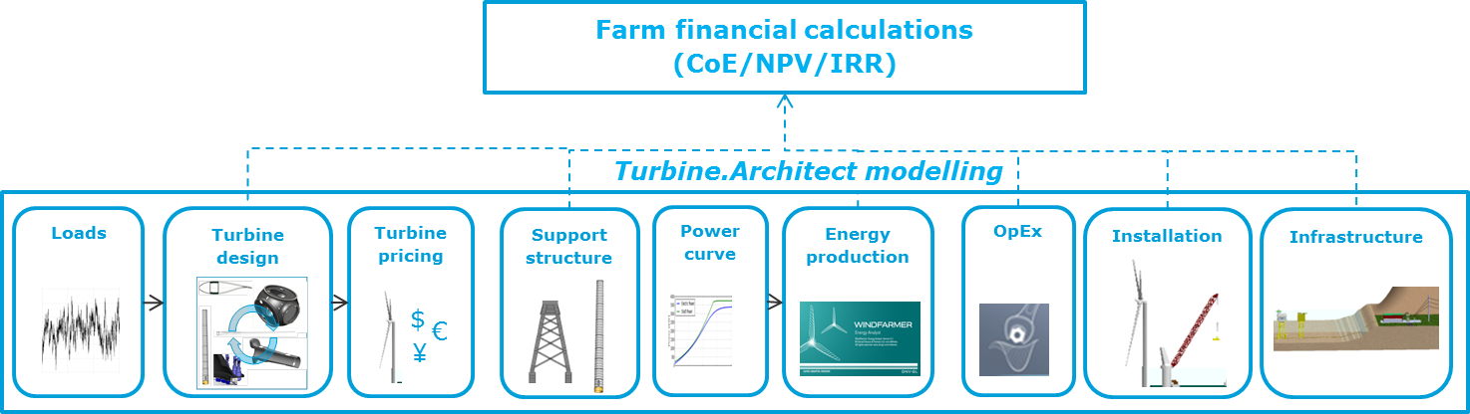

Figure 1: description of the different models contributing to the integrated wind farm financial calculations

introduction
Estimating the Levelised Cost of Energy and yield economic metrics like NPV or IRR of a wind farm can be a challenging process due to the high number of parameters, systems and disciplines involved.
Decision makers could face several problem-solving challenges that could span quite wide in terms of scope.
Addressing techno-economic compatibility, selecting the right machine for a specific site and market, with an eye on potential for future upgrades or life extension could be a common example.
For specific installations, generally offshore, the wind industry is quite limited in terms of suitable machines. Looking at what the market could offer in the next years and getting reliable information on future potential for development, could be a strategic advantage when planning investments time frames.
Wind resource maps are broadly available but costs of energy based maps of new sites could be quite advantageous when selecting tariffs settings or bidding strategies.
Last but not least, LCoE-driven wind farm layouts are well within the capabilities of an integrated approach taking into account all the interacting parameters in a wind farm and not just the resource.

Levelized cost of energy formulation and turbine.architect
In order to understand the foundation of the integrated approach to cost of energy modelling, it is beneficial to analyse the formulation of the levelised cost of energy in Eq.1.

$LCoE=\frac{\sum_{t}{\left(({Investment}_{t}+{O\&M}_{t}+{Fuel}_{t}+{Carbon}_{t}+{Decommissioning}_{t}\right)∙{\left(1+r\right)}^{-t}) }}{\sum_{t}{(Electricity∙{(1+r)}^{-t}})}$ (1)

Levelised Cost of Energy is the result of several elements of costs divided by energy yield.
The various elements contributing to the costs estimate include: investment, operations & maintenance, fuel, carbon tax, and decommissioning costs all divided by the energy captured by the wind farm over the years.
In DNV GL an integrated approach considering different engineering models has been developed and used to assess the effects of the different cost elements:
- Turbine model
- Wind farm model
- Operation and maintenance model.
Due to the high level of interactions between the different models and the amount of information, a Python script has been created to support the service in a robust and consistent way.
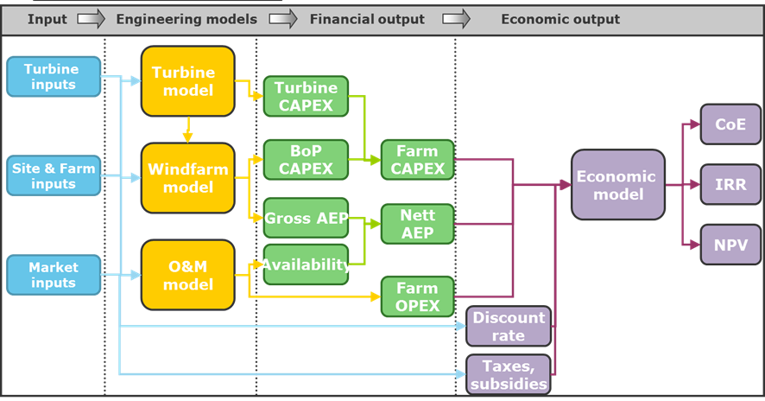
Figure 2: Schematic flow diagram of the cost model

benefits of the Integrated Cost of Energy Modelling
Cost of energy models have been historically a successful tool for new machine concepts developments and technology evaluation. Flexibility, background information, experience and knowledge contained in the overall integrated modelling process has shown a lot of potential in other areas as well. Integrated cost of energy modelling is a very powerful and robust tool when decision making is crucial. Thanks to flexible input capabilities and uncertainty estimation, is possible to support decisions depending on complex interactions, based on sound assumptions.
The main areas of interest when looking at wind farms costs implications are:
- Cost of energy driven machine suitability studies
- Cost of energy mapping
- Cost of energy driven windfarm layout optimization

Cost of energy driven machine suitability studies
Historically suitability studies have been run considering technical parameters as one of the main driver. A range of investigations allow estimating the optimum parameters of machines to be installed on a specific or a series of wind sites. Models of turbines present on the market or still at a conceptual phase can be modelled. Several parameters are involved when running CoE and NPV studies for optimal wind turbine sizes. As an example for a typical onshore installation, the common assumption that bigger is better, is applicable up to a certain point. The increase in size beyond certain limits and for set site conditions could be detrimental in terms of CoE and NPV. Beyond certain dimension limits capital expenditure (CapEx) become quite high and transport and installation costs play a significant role as well. Only by addressing the problem and the interaction of the different parameters involved it’s possible to get a rigorous answer in terms of optimum solution. In Figure 3 a typical output of an optimum rating & diameter study is presented.

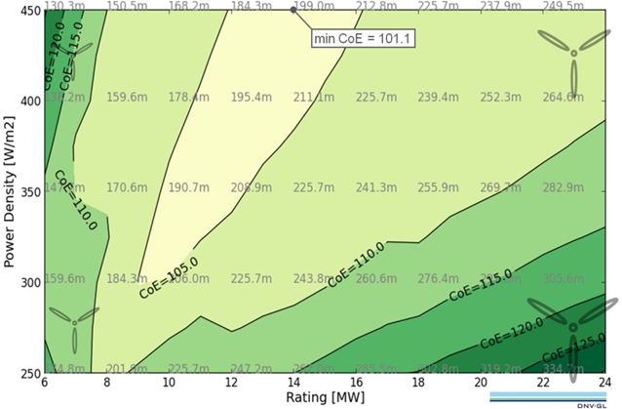
Figure 3: Output of an optimum rating & diameter study
Integrated costs of energy studies are a quite powerful tool when investigating the economic implications of installations related to machines not existing on the market yet.
Thanks to the knowledge of machine trends and related implications in terms of costs, is possible to estimate the effects of the next generation of machines designs on the main economic performance parameters. Strategic studies can be run to investigate the optimum time to invest and the relevant technology to optimize the investment.

cost of energy mapping
As shown in Figure 4, a cost of energy driven map is a powerful tool to provide a snapshot of CoE levels at different sites. This information can help the debate over the choice of new sites thanks to high-fidelity analysis, where the effect of site conditions such as wind, soil type, wave climate & water depth can be taken into consideration. Cost of energy maps could also be instrumental when setting new permits or tariffs alongside bidding strategies.

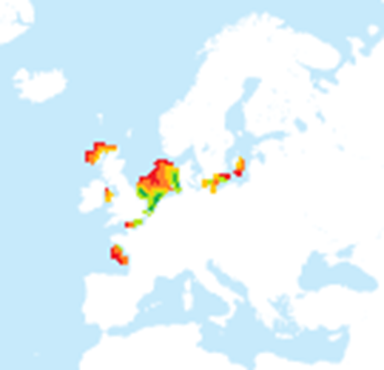
Figure 4: Cost of Energy Mapping

Coe driven windfarm layout optimization
The position and layout of a wind farm has direct effects on: net energy production, project cost
and turbine fatigue loading. In Figure 5 results related to a demonstration study of a 600MW project with 100 x 6MW wind turbines, with bathymetry map for a sloped site and 3 exclusion zones are presented.
The results show different layouts in relation to specific targets: Maximum energy capture, Minimum installation costs and Minimum levelised cost of energy.

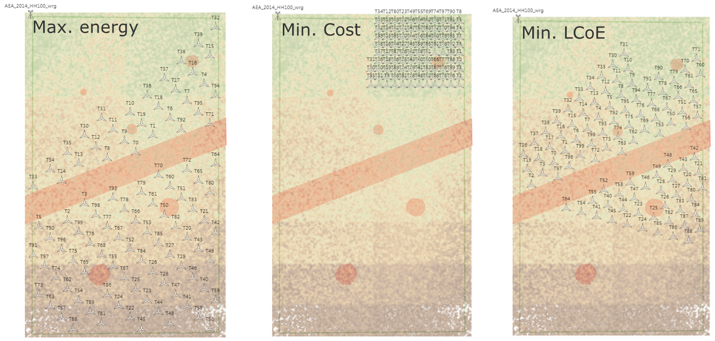
Figure 5: Optimum layout results for different set targets

conclusion
In this study the capabilities of integrated Cost of Energy modelling have been presented. Particular focus has been given to capabilities to support the decision making process of Investors, Governmental Bodies, Wind Farms Owners and Operators. The variety of investigations and the complex interaction of parameters involved clearly define the need for an holistic approach as the right direction to drive forward the reduction in cost of energy produced using wind energy.
REFERENCES
- Peter Jamieson, 2011. Innovation in Wind Turbine Design
- Garrad Hassan & Partners Ltd, Inventory of location specific wind energy cost, GH report 101499/BR/02B, Spatial Deployment of offshore WIND Energy in Europe (WINDSPEED), WP2 Report D2.2, EIE/07/759/S12.499460, July 2009 http://www.windspeed.eu/publications.php?id=19 http://www.windspeed.eu/media/publications/D2.2.pdf
- DNV GL “Wind Turbine Availability Losses White Paper”, June 2012
BIOGRAPHIES
Giuseppe Ferraro is Business Development manager for the DNV GL’ Turbine Engineering Support Department. He is a Mechanical Engineer (MSc), graduated from the University of Catania in 2002. Working as worldwide business development lead for Turbine Engineering Support since 2014 has previously been involved in several wind turbines design projects since joining Garrad Hassan & partners ltd in 2009.

