How Is the Performance of Your Wind Farm? Using SCADA & Inspections to Maximise Yield!

Ferdy Hengeveld, Frans Brughuis
MECAL Wind / Energy
Capitool 15, 7521PL Enschede, the Netherlands
f.hengeveld@mecal.eu , f.brughuis@mecal.eu

SUMMARY
Modern wind farms are treated as power stations, with the operation and maintenance performed by OEMs or dedicated independent service providers, who give guarantees on availability. Nevertheless, despite the huge amount of data that is available, these are often not used effectively. This paper describes a method in which analysis of SCADA data is combined with dedicated inspections, with the purpose to give operators and financers independent insight in the actual performance of their assets. This enables them to reduce risk and maximise the yield and Return on Investment.

Keywords: Wind energy, asset management, performance, SCADA, inspections

INTRODUCTION
Brazil has one of the cleanest energy matrices in the world; more than 80% of the overall energy production comes from renewable sources, compared to the worldwide average of ca 22%. The success of renewable energy in Brazil can be mainly attributed to the development of hydroelectric plants, geographical advantage and to foreign dependency avoidance. In 2014, Brazil ranked 4th in the world concerning new installations of wind power, according to the Global Wind Energy Council (GWEC, ref [1]) and in terms of cumulative installed capacity, Brazil entered the top 10 in 2014 with an impressive 71% increase, passing long-time wind pioneer Denmark.

The success of Brazil is driven by favourable wind resources, a governmental auction (tender) system and sound financing schemes by BNDES, the Brazilian state owned development bank. Within Latin America, Brazil can be considered the most promising market for wind energy in terms of regulations and experiences with an estimated potential of 300GW onshore. According to GWEC, Wind will likely surpass gas in terms of installed capacity by the end of 2017, and assume its place as the ‘No. 2’ power source in the country. This is all the more important given the recent droughts and associated unreliability of the hydropower which is and will continue to be the backbone of the country’s electricity system.

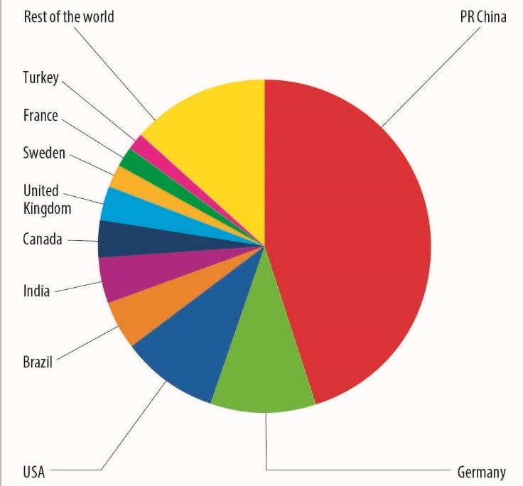
Figure 1 - Top 10 new installed capacity 2014, source: GWEC, ref. [1]

The start of the Brazilian wind energy market was originated by PROINFA (2004), a subsidy driven incentive, which resulted in approximately 1GW of onshore wind farms. In 2009, contract auctions became part of the renewable energy policy, which increased competition and developed the sector. The success of windpower in Brazil gives opportunities as well as large challenges: Not all wind farms that were commissioned in 2014 had a grid connection. Furthermore, the large growth rates strain the supply chain to the limit, with the risk of shortage of components for new turbines.

In this market it is vital that the performance of the existing wind farms is maximised to give maximum return on the investments done. Today, often long term maintenance contracts are used with minimum availability guarantees from the OEM or Independent Service Providers (ISPs). But how can you, as operator or financer, ensure that your wind farm is operating well and not only has a high availability, but also is giving good quality yield without overloading the wind turbine and reducing life time?

This paper discussed methods for independent monitoring of the performance of your wind farm by analysis of the SCADA data, combined with dedicated inspections. This way it is possible to maximise the yield of the windfarm and reduce risks.

APPROACH
Today, wind farms are treated more and more as power stations, instead of a group of wind turbines. Levelised Cost of Energy (LCoE) has the highest priority in the operation. Optimisation of Operation and Maintenance (O&M) is of the utmost importance, facilitated by the almost standardised application of condition monitoring systems and extensive SCADA.

However, in many cases, the historical SCADA data is stored without using the full potential of it. Operators and financers can see e.g. that the availability of their wind farm is high, but cannot check if the actual production matches the expectations or if the current wind turbine setup does not lead to overloading of the turbine and a reduced life time.

MECAL has developed a systematic approach to analyse the actual performance of wind farms. At the basis of this is the combined knowledge of more than 20 years of wind turbine design experience and results of more than thousand wind turbine inspections as well as SCADA data and historical failure data. All information is stored in the MECAL Intelligence Database (MInD™), Figure 2.

The MInD™ based analysis of wind farms combined with dedicated inspections on the wind turbine gives data driven insight in the causes for sub-optimum performance and helps operators to improve the Return on Investment of their assets.
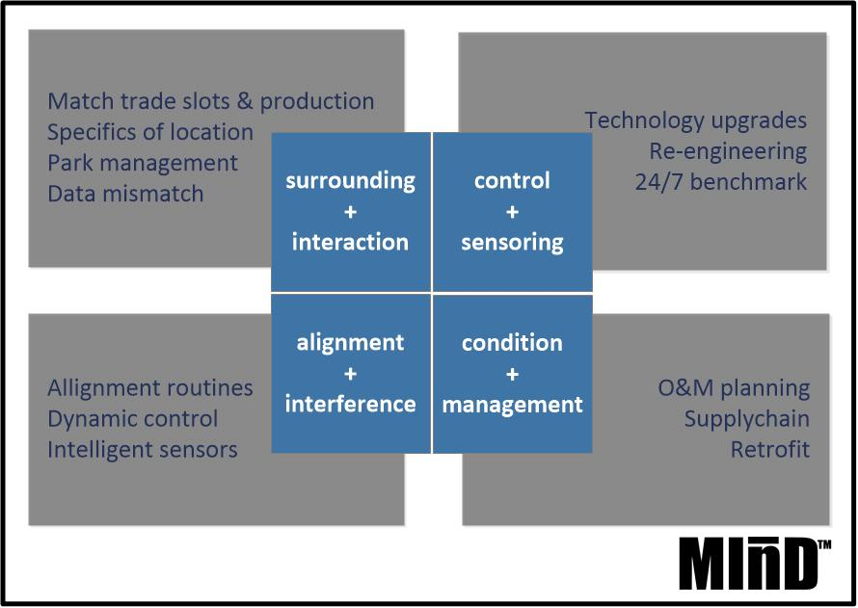

Figure 2 – MECAL Intelligence Database MInD™

APPROACH

The performance of wind turbines in a wind farm is influenced by three aspects:
- Wind resources (is there sufficient wind?)
- Performance of the turbine (is the wind turbine performing as expected for the given wind conditions? Is it not overloaded?)
- Reliability of the turbine (Can the turbine operate often enough? Are there long downtimes?)
When analysing and improving the performance of a wind farm it is very important to define the root cause of yield deficiency in order to come to proper countermeasures for improvement: If the wind resources are much lower than originally expected, countermeasures to increase reliability or performance may help, but will not remove the cause of the lower yield.

The wind farm performance analysis is done in 4 steps (Figure 3). The performance of the individual turbines is compared to the other turbines as well as similar turbines in the MInD™ database.

Figure 3: wind farm performance analysis

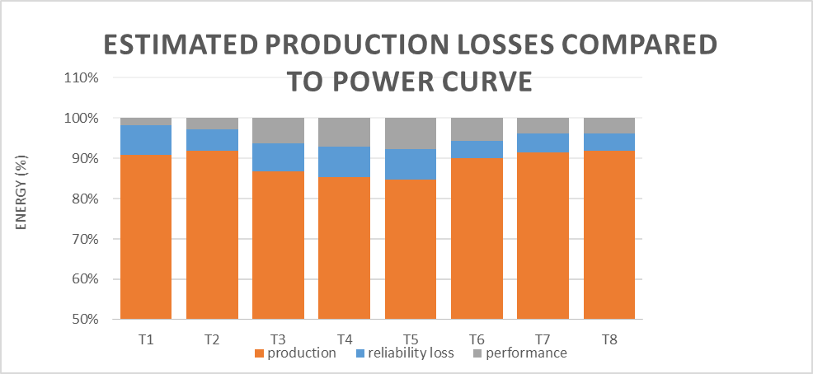
The outcome of this process is an estimation of the production losses. An example of this is given in Figure 4.

Figure 4: Example of wind farm performance analysis

Based on this outcome, the next steps are defined:
- In case of performance loss, the losses are often caused by misalignments, such as misalignment of the yaw angle, suboptimum control system settings or misaligned blades, resulting in aerodynamic imbalance. Aerodynamic imbalance does not only lead to lower yield, it also causes large vibrations in the wind turbine with high fatigue loading and a shorter technical life.
Dedicated inspection and measurements will support in root cause determination. Depending on the situation, vibration measurements or endoscopic inspections in the gearbox are done. Due to the initial analysis it is possible to restrict the inspections to only those turbines with expected issues. This way, optimum use is made of manpower.

- Reliability losses are visible as wind turbine downtime. Especially unscheduled maintenance is a cause for severe downtime, when spare parts or service crews are not available. In order to analyse the cause for reliability losses, algorithms are developed to find the cause for downtime from basic SCADA counters, ref. [2]. Through the counters (Turbine OK, Service On, Alarm On) the state of the wind turbine can be defined and thus the downtime events. The total downtime for each event is separated into response time, service time and duration, combining the methodologies developed for e.g. Reliawind (ref. [3]). As a result, basic reasons for long downtime events can be identified (e.g. lack of spare parts that led to logistic delays, low crew responsibility). For the different failures (manual restart, minor repair, major repair) different statistical assumptions are made to model and simulate the situation after repair: In case of manual restarts or minor repairs it is assumed that the WTG is partially or not at all improved compared to its state before the failure (as bad as old). On the other hand, it is feasible that after a major repair the assembly was thoroughly repaired or fully replaced, making the component as good as new. In order to transfer the results of wind farms to others, the influence of the environmental conditions is taken into account, so that the reliability figures will be adjusted accordingly.
The result of this gives an indication of the reasons for suboptimum operation of the wind farm and is used to define improvements, e.g. in O&M strategy.

CASE STUDY
On request of a large operator, MECAL has analysed the performance of a European wind farm consisting of 14 wind turbines of the 2-3MW class. The wind farm has a full service contract with availability guarantees. Nevertheless, the operator wanted to have an independent review of the wind farm performance as a second opinion on the existing reporting from the OEM. The project was started with an analysis of the SCADA data, following the process described before.

It was concluded that the availability was equal or better than the guaranteed values, but the performance of some wind turbines was lower than others. Based on assessment of local conditions and comparison of power curves (Figure 5), it was concluded that production losses were likely caused by a misalignment of the yaw angle of the turbine towards the wind direction. This does not influence the availability, but of course leads to suboptimum performance as the wind turbine feels less wind.
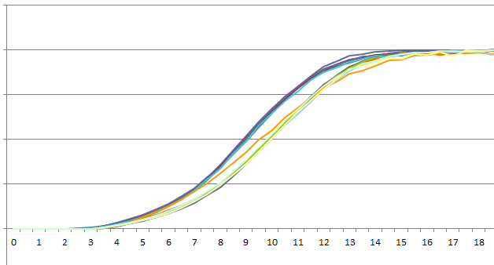

Figure 5: Power curve comparison

In the following measurement campaign on three selected wind turbines using nacelle based LIDAR it was found that the yaw angle misalignment amounted to ca 8.4 [deg] for the least performing turbine and was also significant for the others. Due to local conditions, the actual deviation of yaw angle increased for higher wind speeds.

After correction the performance was measured again over a longer period. It was concluded that the correction resulted in an increase of yield of almost 2% for a single wind turbine, or ca BRL7000 per wind turbine per year.

Given the small size of the investigated European wind farm compared to Brazilian wind farms, the total expected yield increase will be significant on wind farm level.

CONCLUSIONS
Wind energy is becoming an important part of the energy mix in Brazil and is growing rapidly. The trend that wind farms are operated with long term O&M contracts including availability guarantees by OEMs or independent service providers, is also visible in Brazil. Despite these guarantees, it is important that the operators and financers have insight in the performance of their assets. The method developed by MECAL combines smart analyses of statistics with SCADA data and dedicated inspections and measurements. This will lead to optimised performance of the wind farm and maximised asset management.

REFERENCES
- Global Wind Energy Councel (GWEC), Global Wind 2014 Report, Annual Market Update, 2015
- Kaidis, C., Amoiralis, F., Uzunoglu, B., Wind turbine reliability estimation for different assemblies, failure severity categories and environmental conditions using SCADA data, Proceedings of EWEA 2014, Barcelona, Spain
- Reliawind, 2011. The Reliawind consortium official website. [Online] Available at: http://www.reliawind.eu/

BIOGRAPHIES
Ferdy Hengeveld (11 Feb 1975, Aalten, the Netherlands) has a Bachelor degree in Mechanical Engineering, obtained Cum Laude at the Saxion University of Applied Sciences in Enschede, the Netherlands (1998) with a focus on Energy Technology.

Throughout his career, he has worked in renewable energy, with a strong focus on wind turbine technology. Currently, he is heading MECAL Wind/Energy, where he and his team are supporting OEMs and operators/owners of wind farms by improving their products and assets in order to lower the cost of energy of wind power. Furthermore he is part of the Management Team of MECAL.

Ing. Hengeveld is member of the NEC88 subcommittee that is defining the guidelines for extended operation of wind farms in the Netherlands.

Frans Brughuis is born in Groningen, The Netherlands, on 24th of October 1958. He has a bachelor degree in Mechanical Engineering, earned on the Technical College in Enschede, The Netherlands (1981).
He is one of the founders of the engineering company MECAL. He has 25 years of experience in the field of wind energy. In 1991 he has set up MECAL’s Wind Turbine Design department that is specialised in design, design optimisation and strength assessments of complete wind turbines. Between 2005 and 2011 he has lead MECAL’s subsidiary Advanced Tower Systems (ATS), where he developed and built precast concrete towers for wind turbines with hub heights between 100 and 150m. At this moment he is non-executive member of the board and initiates new, innovative developments for MECAL Wind/Energy.
He is member of:
• the IEC committee TC 88 MT1 and PT 61400-3-2
• the FIB task group 6.14

