Sensitivity Analysis of Waveform Distortion Assessment for Wind Plants

Mariana B. Pereira1, Einar V. Larsen2, Sebastian A. Achilles3

Energy Consulting

General Electric

1 Av. Magalhães de Castro 4800, São Paulo-SP, 05502-001, Brazil

2, 3 1 River Road, Schenectady-NY, 12345, USA

[mariana.bindapereira@ge.com](mailto:mariana.bindapereira@ge.com), [einarv.larsen@ge.com](mailto:einarv.larsen@ge.com), [sebastian.achilles@ge.com](mailto:sebastian.achilles@ge.com)

Abstract

In this paper the waveform distortion assessment of wind plants based on main standards is evaluated, and recommendation is given on appropriate modeling of wind turbines. The proposed wind turbine representation includes a Norton-equivalent circuit including both a self-impedance and a current source. A typical wind plant design is used to evaluate the impact of modeling considerations in harmonic assessment results. A sensitivity analysis is done to understand the influence of key parameters on distortion levels at the point of interconnection.

**Index Terms:** *Distortion measurement, power conversion harmonics, resonance, wind power generation*

# INTRODUCTION

Wind power plants are considerable increasing its participation in the electrical network of diverse countries and regions. This increasing share requires more dedicated regulations in order to preserve the power quality and reliability of the system. Several countries are adapting their grid codes with sections specific for wind energy and addressing in depth the particularities of this power source. This article focuses on the subject of power quality, specifically on distortion emission assessment of wind plants.

In general, grid codes and utilities refer to existing standards and guidelines when requesting harmonics assessment as part of the due diligence to obtain grid connection permit. Most referred standards and guidelines are:

* IEEE Std 519-1992, “Recommended Practices and Requirements for Harmonic Control in Electric Power Systems” [1].
* IEC 61400-21 Ed. 2.0, “Measurement and assessment of power quality characteristics of grid connected wind turbines” [2].
* BDEW June 2008, “Generating Plants Connected to the Medium-Voltage Network” [3].

The first and third were written for general purpose and not specific for wind plants, whereas the second is specific for wind turbines. It is common to see conservative interpretation of these guidelines which leads to assessment methods at plant level that in most cases yields higher estimated distortion values than the actual measured performance after commissioning. Experience with many wind plants of the manufacturing company associated to the authors indicates that the waveform distortion issues are generally not a practical problem. In the few instances where a problem has been observed, it is due to resonances in the collector system and background distortion, rather than distortion energy created by the wind turbines.

The objective of this article is to outline the common methods of harmonics assessment based on the listed guidelines, describe the physics of wind generators with respect to waveform distortion, and recommend adjustments to harmonic distortion assessments to better represent the practical considerations that should be included when designing a wind plant.

# Summary of assessment methods Based on standards

## General Summation Law

A general summation law of the distortion of several wind turbines in a wind plant is recommended on IEC 61400-21 [2], and is adapted as:

|  |  |  |
| --- | --- | --- |
|  | $$I_{hΣ}=\sqrt[β]{\sum_{i=1}^{N_{wt}}{{\left(I_{h,i}\right)}^{β}}}$$ | (1) |

Where:

IhΣ = is the h’th harmonic current distortion at the Point of Evaluation (POE) due to the wind turbines;

Nwt = number of wind turbines connected to the POE;

Ih,i = is the contribution from the i’th wind turbine to the h’th harmonic current distortion at the POE;

β =1 for h<5, =1.4 for 5≤h≤10, =2 for h>10;

Similar summation law is recommended in the standard BDEW June 2008, with β=1 for h<13, β =2 for h≥13 [3].

The β exponent is proposed in order to account for the harmonic energy from different sources being non-synchronous. For lower-frequency distortion it is assumed that the sources are generally close to synchronism thus the currents will add arithmetically. However for higher-frequency components there will be more of a random relationship of phasing, therefore better considered as a root-mean-sum combination.

## Distortion at POE: Simplistic approach

A simplistic application of (1) assumes that each wind turbine is an ideal current source with magnitudes equal to measured distortion and that the wind plant electrical equipment does not absorb any distortion. With this simplification the voltage distortion at the POE is simply the aggregated current times the grid impedance beyond the POE. Figure 1 below illustrates this simplistic approach.



Figure 1. Simplistic Electrical Circuit of Wind Plant.

The assumptions in this approach are normally not valid for practical wind plants. The wind plant collector system has a significant effect on the flow of distortion currents, as well as any shunt capacitor added for power factor correction. In addition, the current distortion measured at a wind turbine is not independent from the characteristics of the grid. Hence, ideal current sources would not be a valid representation. Neglecting plant equipment will lead to incorrect and normally pessimistic assessment of total distortion due to energy created by the wind turbines, and will fail to identify possible resonant conditions that can lead to field problems.

## Total Distortion Definition

The total harmonic distortion is then calculated using the distortion levels at all frequencies as shown in the following equations [4]:

|  |  |  |  |
| --- | --- | --- | --- |
| $$THV=\sqrt{\sum_{h=2}^{H}{{\left(\frac{V_{h}}{V_{1}}\right)}^{2}}}$$ | (2) | $$THI=\sqrt{\sum_{h=2}^{H}{{\left(\frac{I_{h}}{I_{1}}\right)}^{2}}}$$ | (3) |

Where:

THV, THI = total harmonic distortion of harmonic voltage and current respectively;

Vh, Ih = is the harmonic voltage and current of the h’th order;

V1, I1= is the nominal voltage and rated current of the wind plant at full load;

H = is generally 40 or 50 depending on the application;

## Distortion Limits

Distortion limits are given by each grid operator and are normally based on the recommendations of one of the standards listed in this paper. If the POE is shared with other power plants, the distortion limits for each plant can be calculated from the global limits at POE. Equation 4 is suggested by IEC 61000-3-6 [4]:

|  |  |
| --- | --- |
| $$E_{hi}=G_{h}\sqrt[β]{\frac{S_{i}}{S_{T}}}$$ | (4) |

Where:

Ehi = is the h’th distortion limit of the individual installation;

Gh = is the h’th maximum global distortion limit at the POE;

Si = is the agreed power of the individual installation;

ST = is the total supply capacity of the considered system including future load growth;

β = same as for Eq. (1);

The harmonic assessment calculation results can be checked against the individual plant limits.

# Practical considerations

## Wind Turbine Physical Representation

As with conventional generators, the wind turbine harmonic behavior is closer to a voltage source behind an impedance. This is generally true for both dual-fed and full-converter wind turbines. This behavior has the effect that the harmonic currents flowing at a wind turbine generator vary depending on the system impedance and background distortion. In addition and similar to synchronous generators, this type of behavior results in wind turbines being a low impedance path to harmonic distortions from the grid.

The appropriate means of representing wind turbines for evaluation of grid distortion is with Thevenin or Norton equivalents. The proposed representation in this paper is a Norton equivalent, with a frequency dependent impedance to represent the absorption of distortion energy, and a current source to characterize distortion energy created by the wind turbine, as shown in Fig. 2 [7].



Figure 2. Norton-Equivalent Circuit for Evaluating Wind Generator Distortion.

Most distortion created by a wind turbine is at high frequencies (high order harmonics and interharmonics close to the converter switching frequencies), and is attenuated before leaving the wind plant by filtering elements within the wind turbine, and by the collector system capacitance.

## Measurements Interpretation

Harmonic distortion measurements at wind turbine terminals and related reports are described in IEC 61400-21 [2]. These measurement procedures typically report the harmonic currents observed at wind turbine terminals.

As described in previous sections, wind turbines present low impedance path for grid harmonics. Hence, the harmonic currents observed at the terminals of a wind turbine include:

* Harmonic distortion currents generated at the wind turbines flowing to the grid
* Harmonic distortion currents generated in the grid flowing into the wind turbine

These measurement guidelines do not differentiate the distortion generated by a wind turbine from the distortion flowing from the grid to the wind turbine.

Based on simulation including converter and converter control detailed design characteristics, a harmonic Norton equivalent of a GE1.6 wind turbine was generated. This characterization was then verified against field measurements. The current spectrum associated to the Norton source is simulated and confirmed with measurements for different turbine active power levels. For each frequency, the highest harmonic emission of all active power levels is used. That is, the current spectrum represents the worst case scenario.

Figure 3 shows a comparison between measured data according to IEC61400-21 Ed. 1, at the terminals of a GE 1.6 MW wind turbine and the harmonic currents of the Norton equivalent source [7-8].

It can be observed that at high frequencies (30th and 32nd orders), close to the switching frequency of the converter, the generated currents are higher than the measured currents. This is because the harmonic distortion filters in the wind turbine represent a low impedance path to these high frequencies and absorb most of the distortion generated by the wind turbine. In the Norton equivalent this is characterized by the Norton impedance being lower than the system impedance.

At lower frequencies (5th order) the opposite is observed, the measured current distortion is higher than the distortion generated at the wind turbine. This is related to harmonic energy from the grid into the wind turbine. The wind turbine has relatively low impedance at this frequency; it absorbs harmonic current reducing the harmonic voltages in the system. As a reference point, this particular turbine is expected to absorb around 2% harmonic current of 5th order for a 1% terminal voltage distortion at this frequency due to grid distortion.

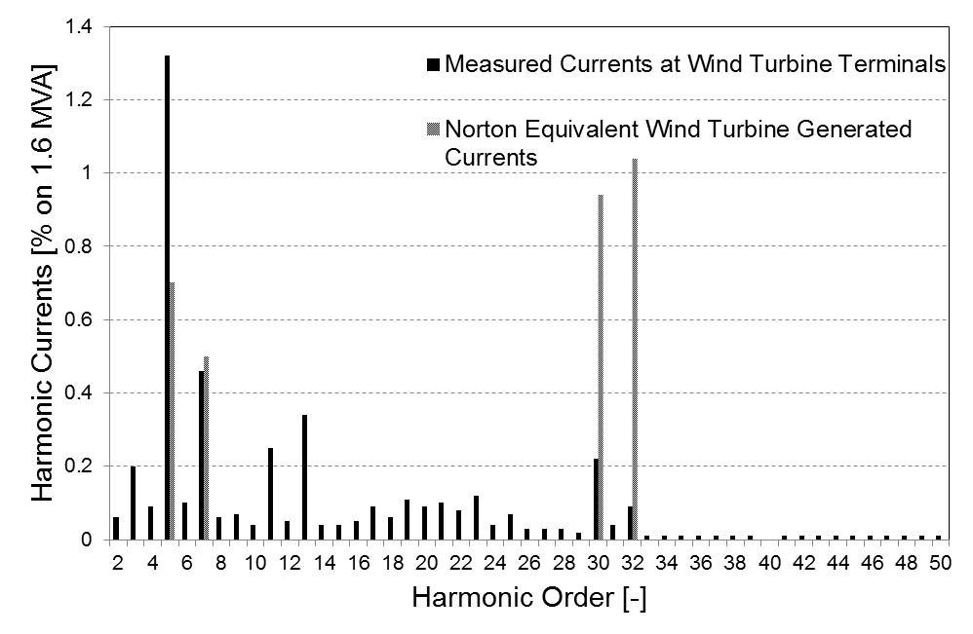

Figure 3. GE 1.6MW Harmonic Currents Spectrum Measured at Wind Turbine Terminals and Norton Equivalent Generated.

Assuming that harmonic current distortion measured at the terminals of a wind turbine is representative of the distortion generated at the wind turbine is hence invalid.

## Wind Plant Resonances

The collector system and shunt capacitors of a wind plant can form lightly-damped resonances. These resonances are an important factor that shall be considered when designing a wind plant electrical system, to avoid amplification of harmonic distortion coming from the grid. This is particularly relevant in wind plants with shunt raw capacitors for power factor compensation.

Assessment work to determine this type of resonances assuming the turbines are ideal current sources (infinite Norton impedance) will, in most cases, not reproduce the actual system behavior. In this case, study results may be optimistic or pessimistic depending on the characteristics of the application. The Norton impedance of wind turbines can have a noticeable effect on resonant frequencies, and will decrease with increasing number of turbines in operation, absorbing more current distortion from the grid. In this regard, the primary concern is for frequencies below 1 kHz. At these frequencies, the shunt capacitance of the collector system does not significantly prevent the grid harmonics components to flow into the wind turbine.

# Recommended Practice

## Wind Plant Harmonic Distortion Assessment

The impedances of cables and lines, transformers, capacitor banks, wind turbines and grid shall be considered in harmonic distortion assessment of wind plants in order to include the resonance behavior of the plant system [5].

A representation of the electrical circuit which includes key elements for harmonics assessment is shown on Fig. 4. ZN,par is the wind turbine Norton impedance divided by the number of wind turbines; ZCS, par is the aggregated collector system capacitance; Zmain trf is the impedance of the main wind plant transformer; and ZGrid is the system impedance seen from the POE. The high frequency damping of the collector system and main transformer were considered in this representation.



Figure 4. Proposed Simplified Electrical Circuit of Wind Plant.

The aggregated distortion current source IN,sum represents all wind turbines and can be estimated according to (1). This circuit can be used to estimate the current IPOE and voltage VPOE distortion at the POE, due to the wind turbines. A current-gain that relates the current seen at the POE and the current injected by the wind turbines Norton equivalent can be determined as a function of the impedances, as shown in next equation:

|  |  |
| --- | --- |
| $$K_{I}=\frac{I_{POE}}{I_{N,sum}}=\frac{Z_{N,par}Z_{CS}}{Z_{N,par}\left(Z_{Grid}+Z_{main trf}+Z_{CS}\right)+Z_{CS}\left(Z_{main trf}+Z_{Grid}\right)}$$ | (4) |

The grid impedance at the harmonic frequencies varies with load level, capacitor bank status, line outages and generation status. It is recommended to perform studies with many combinations of grid impedance to cover the most significant cases. The grid impedance spectrum or the grid information necessary to build the spectrum is normally provided by the grid operator. In some cases it is also recommended to consider future grid scenarios.

## Example 1: Typical Wind Plant Using Physically-Valid Representation

An example with realistic wind plant and utility system characteristics was used to illustrate an assessment considering the modeling guidelines of Section 2.2 and Section 3.1.

A wind plant of 200 MW with 125 units of GE 1.6 MW wind turbines was considered. The collector system is represented with a capacitance of 100 kVAR per wind turbine. The main step-up transformer has a 12% short circuit impedance and a rated power of 220MVA. The utility grid impedance is derived considering a Short Circuit Ratio (SCR) of 3 at MV level and is presented in the next figure. A 100 MW base is used in all plots.

|  |  |
| --- | --- |
|  |  |
| Figure 5. Grid Impedance Spectrum of Simulated Typical Grid. | Figure 6. Impedance Spectrum seen from Wind Turbines and POE/terminals current relationship. |

The grid impedance at POE shows a resonance behavior at 300 Hz (5th order), Fig. 5. The wind turbine generators in this example are represented with the Norton-equivalent impedance and current spectrums shown in the graph of Fig. 3 [7].

The impedance spectrum seen at the terminals of the wind turbines (Zeq) is presented in Fig. 6. It presents parallel resonances at 840 Hz (14th order) and at 1800 Hz (30th order) due to capacitance of the grid and of the collector system. The current relationship POE over WTG terminals (Ki) follows the same resonance driving-point of the equivalent impedance and is also presented in Fig 6.

The voltage and current distortion spectrums at the POE due to the wind turbine generators are given in the following figures. The maximum current distortion values occur close to the frequencies of parallel resonances. The maximum voltage distortion occurs at 300 Hz (5th order) which has the voltage amplified due to the maximum Zgrid value at this order. The estimated distortion levels are significantly lower than the most strict limits, e.g. of 1% at 5th order. The frequencies with distortions are 300 Hz (5th order), 420 Hz (7th order), 1800 Hz (30th order) and 1920 Hz (32nd order). The distortions in 30th and 32nd orders are considerably reduced at the POE because the collector system capacitance absorbs an important portion of the harmonic currents from the WTGs at these frequencies. Additionally, the high frequency damping of the collector cables and the main transformer are important for the realistic estimation of currents at 30th and 32nd orders at the POE. The calculated THI value is 0.16% and the THD value is 0.06% for this example.

|  |  |
| --- | --- |
|  |  |
| Figure 7. Harmonic Current Spectrum at POE Caused by the Wind Turbines. | Figure 8. Voltage Distortion Spectrum at POE Caused by the Wind Turbines. |

## Example 2: Simplistic Methodology

A new assessment was done using the measured currents shown in Fig. 3, for a SCR of 3, using the simplistic schematic proposed in Fig. 1, excluding collector system capacitance and wind turbine Norton impedance. The measured currents do not exclude grid distortion, so the spectrum has mostly higher values for each harmonic frequency, and the currents are not retained inside the wind farm due to cable capacitance.

These factors result in THI of 0.85% and THV of 0.4%, values up to 6 times higher than previous results, . Still the values are lower than strict limits of e.g. 2%. Next figure shows that the 5th order is the dominant in the THV results.



Figure 18. Voltage Distortion Spectrum at POE with Data of Measured Currents.

With this methodology the resonance points including the contribution from the wind park are not identified. This may lead to misinterpretation of real conditions, and inaccurate implementation of filters.

# Conclusion

Waveform distortions at the POE caused by wind turbine converters are very low. Experience across GE’s extensive fleet of wind turbines shows very few cases where harmonics are excessive. In all of those cases the main issue was distortion energy coming from the grid rather than from the wind turbines, with resonances on the collector system amplifying the external energy. Therefore GE recommends a practice where this experience indicates risks may exist.

To evaluate the risk of high distortion, it is important to study the wind farm using models that represent the physical characteristics of the equipment. For the wind plant this means including the charging current of the collector system, the impedance of the main transformer, and a wind turbine model that properly reflects its self-impedance characteristic.

# References

1. IEEE Recommended Practices and Requirements for Harmonic Control in Electrical Power Systems, IEEE Standard 519-1992, April 12, 1993.
2. Measurement and assessment of power quality characteristics of grid connected wind turbines, IEC Standard 61400-21, Ed. 2.0, August, 2008.
3. Generating Plants Connected to the Medium-Voltage Network, BDEW Technical Guideline, June, 2008.
4. Assessment of emission limits for the connection of distorting installations to MV, HV and EHV power systems, IEC Standard 61000-3-6, Ed. 2.0, February, 2008.
5. R. A. Walling, D. Mueller, “Harmonics and Resonance Issues in Wind Power”, IEEE PES Wind Plant Collector System Design Working Group, IEEE PES General Meeting in Detroit-MI, July 26, 2011.
6. G. Bartak, H. Holenstein, J. Meyer, “Technical Rules for the Assessment of Network Disturbances”, Ed. 2, 2007.
7. Wind Turbine Generator Systems 1.6 60 Hz - Harmonic Distortion, General Electric Company, Schenectady, NY, 2012.
8. Wind Turbine Generator Systems 1.6 Series - Power Quality Measurement Report, General Electric Company, Schenectady, NY, 2012.

# BIOGRAPhies

**Mariana Binda Pereira**– Born on Vitória, Brazil on 14th September 1983. Holds a degree in Master of Science in Renewable Energies from Oldenburg Universitaet in Germany from 2010, and a Bachelor Degree in Electrical Engineering from Universidade Federal do Espírito Santo in Brazil from 2007.

She joined GE Energy Consulting in September 2012, as part of Latin American group, located in São Paulo, Brazil. She is currently Senior Engineer working mostly with interconnection studies of wind generation into the bulk power system, for diverse projects throughout the world. Her main work includes power plant load flow and dynamic electromechanical simulations, and power quality studies to investigate grid code compliance and optimum control settings of GE machines (wind turbines, gas engines, among others), using PowerFactory and PSLF software. She is active in Brazilian working groups related to wind power integration.

**Einar V. Larsen** has worked in the electric power industry since 1972, mostly engaged in power system engineering with the General Electric Company. He has led many developments in system control for generators and large power electronic systems, and related studies of grid interactions. He has recently led much of the grid-interface aspects of wind generators for GE. He is a Fellow of IEEE and a member of the US National Academy of Engineering.

**Sebastian Achilles** – Born in Argentina in 1972. He studies electrical engineering in the Universisdad Nac de La Plata and a masters in Electric Power Systems from Rensselaer Polytechnic Institute in Troy,NY. He leads the power system team from GE Energy consulting in Latin America.

He is an IEEE and CIGRE member. He is a secretary of the CIGRE working group B4.62 on connection of wind farms to weak AC systems.